The Konstruct
(working title)
Design By: Ron O’Hara

Server Structure Design

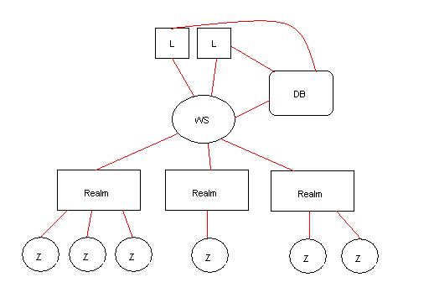
L = Login Server
DB = Database Server
WS = World Server
Realm = Realm Server
Z = Zone Server

Server Manager
The server cluster will be made up of any number of physical machines. The cluster will be managed by a single process. All available physical machines will register themselves with the manager and continually update their usage status. The manager will be responsible for spawning and assigning tasks on individual machines as dictated by load conditions.

Login Server
A login server will handle connections directly from the internet. This server will be responsible for negotiating a session, validation of credentials, and opening a connection with the world server. There can be any number of login servers as load requires. Login servers communicate directly with the database server as well as the world server. A typical communication with the login server would consist of:
- The client sending its credentials
- Validating the credentials with the database server
- Securing a connection for the client with the world server
- Transfer the client connection to the world server

Database Server
The database server will be responsible for all persistent data. Data will be stored in a SQL database and accessed by the database server process. Various other servers will send read/write requests to the database server which will then be cached and handled.

World Server
The world server is responsible for managing all the realms that are open. When new realms are created, it is the world server’s job to instantiate and setup the new realm. The world server is also responsible for the global chat and global system functions.

Realm Server
The realm server is responsible for managing all rules and players of the realm.

Zone Server
These are the grunt-work processes, the workload of updating various things within a realm are divided among all of the zone servers currently available to a given realm.

